
ТЕХНИЧЕСКИ УНИВЕРСИТЕТ – ВАРНА
Факултет по изчислителна техника и автоматизация
Катедра „СИТ“
КУРСОВ ПРОЕКТ
по дисциплината Програмиране на бази данни
на тема Управление на персонал
Вариант 9

Изготвил: Теодора Стойчева
Специалност: СИТ
Група: 4-б
Факултетен номер: 22621693
2025

Задание
Да се проектира и реализира база от данни за управление на персонал във фирма, която съхранява следната информация:
- Служител - име, фамилия, код на длъжността, име на длъжността, отдел, заплата, дата на постъпване, езици
- Присъствия и отсъствия по болест или отпуск в брой дни за всеки месец на служител

Ограничения:
- Всеки служител може да е назначен в само един отдел
- Всички служители може да имат само по една професия

Базата трябва да е нормализирана.
Трябва да поддържа следните действия:

1. Въвеждане и корекция на данни
2. Търсене на служители по име на длъжност, код на длъжност, отдел, език, заплата
3. Справка за последните 5 назначени служители, подредени по дата на назначаване
4. Справка за назначените служители за период
5. Справка за служителите без отсъствия в даден месец

3.Модели
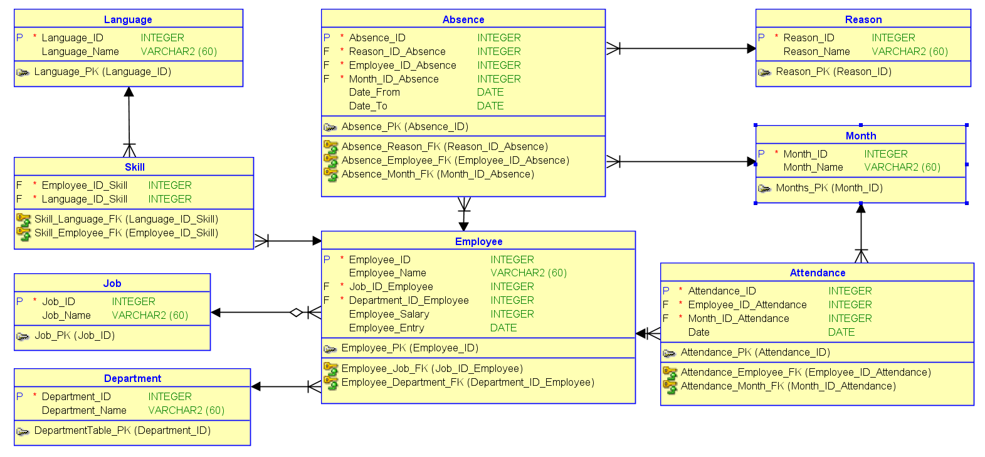
  - Релационен модел

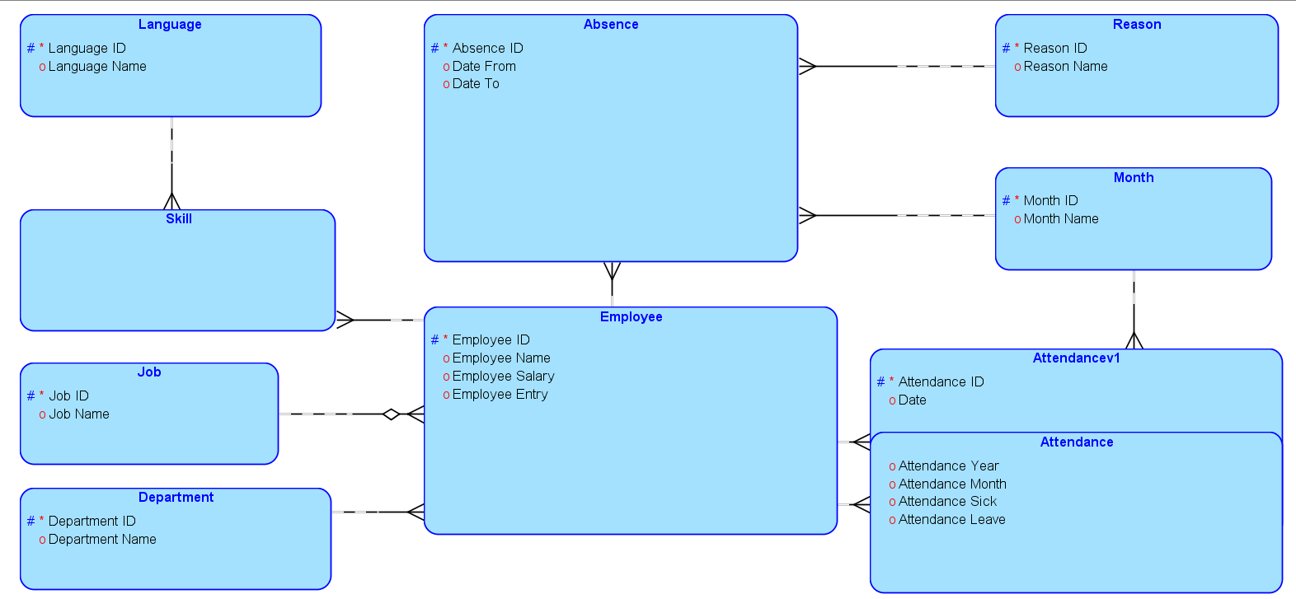
  - Логически модел

.

4. Създаване и свързване

4.1. Отсъствия

create table absence (
absence_id integer not null,
reason_id_absence integer not null,
month_id_absence integer not null,
daysnumber integer
);
alter table absence add constraint absence_pk primary key ( absence_id );

4.2. Присъствия

create table attendance (
attendance_id integer not null,
month_id_attendance integer not null,
daysnumber integer
);
alter table attendance add constraint attendance_pk primary key ( attendance_id );

4.3. Отдели

create table department (
department_id integer not null,
department_name varchar2(60)
);
alter table department add constraint departmenttable_pk primary key ( department_id );

4.4. Служители

create table employee (
employee_idinteger not null,
employee_name varchar2(60),
job_id_employee integer not null,
employee_salary integer,
employee_entry date
); alter table employee add constraint employee_pk primary key ( employee_id );

4.5. Позиции

create table job (
job_idinteger not null,
job_name varchar2(60),
department_id_job integer not null
); alter table job add constraint job_pk primary key ( job_id );

4.6. Езици

create table language (
language_id integer not null,
language_name varchar2(60)
); alter table language add constraint language_pk primary key ( language_id );

4.7. Месеци

create table month (
month_id integer not null,
month_name varchar2(60)
); alter table month add constraint months_pk primary key ( month_id );

4.8. Причини за отсъствие

create table reason (
reason_id integer not null,
reason_name varchar2(60)
); alter table reason add constraint reason_pk primary key ( reason_id );

4.9. Запис

create table sheet (
sheet_idinteger not null,
year integer,
employee_id_sheet integer not null,
absence_id_sheet integer not null,
attendance_id_sheet integer not null
); alter table sheet add constraint yearsheet_pk primary key ( sheet_id );

4.10. Говорими езици

create table skill (
employee_id_skill integer not null,
language_id_skill integer not null
);

4.11. Връзки

alter table absence
add constraint absence_month_fk foreign key ( month_id_absence )
references month ( month_id );

alter table absence
add constraint absence_reason_fk foreign key ( reason_id_absence )
references reason ( reason_id );

alter table attendance
add constraint attendance_month_fk foreign key ( month_id_attendance )
references month ( month_id );

alter table employee
add constraint employee_job_fk foreign key ( job_id_employee )
references job ( job_id );

alter table job
add constraint job_department_fk foreign key ( department_id_job )
references department ( department_id );

alter table sheet
add constraint sheet_absence_fk foreign key ( absence_id_sheet )
references absence ( absence_id );

alter table sheet
add constraint sheet_attendance_fk foreign key ( attendance_id_sheet )
references attendance ( attendance_id );

alter table sheet
add constraint sheet_employee_fk foreign key ( employee_id_sheet )
references employee ( employee_id );

alter table skill
add constraint skill_employee_fk foreign key ( employee_id_skill )
references employee ( employee_id );

alter table skill
add constraint skill_language_fk foreign key ( language_id_skill )
references language ( language_id );

alter table sheet
modify absence_id_sheet int null;

5. Въвеждане на примерни данни
(за четимост са показани първите 5 реда от всяка таблица)

5.1. Отсъствия

insert into absence (absence_id,reason_id_absence,month_id_absence,daysnumber) values (1,1,1,2);
insert into absence (absence_id,reason_id_absence,month_id_absence,daysnumber) values (2,2,2,2);
insert into absence (absence_id,reason_id_absence,month_id_absence,daysnumber) values (3,3,3,2);
insert into absence (absence_id,reason_id_absence,month_id_absence,daysnumber) values (4,4,4,1);
insert into absence (absence_id,reason_id_absence,month_id_absence,daysnumber) values (5,1,5,4);

5.2. Присъствия

insert into attendance (attendance_id,month_id_attendance,daysnumber) values (1,1,18);
insert into attendance (attendance_id,month_id_attendance,daysnumber) values (2,2,18);
insert into attendance (attendance_id,month_id_attendance,daysnumber) values (3,3,18);
insert into attendance (attendance_id,month_id_attendance,daysnumber) values (4,4,19);
insert into attendance (attendance_id,month_id_attendance,daysnumber) values (5,5,16);

5.3. Отдели

insert into department (department_id,department_name) values (1,'management');
insert into department (department_id,department_name) values (2,'sales');
insert into department (department_id,department_name) values (3,'finance');

5.4. Служители

insert into employee (employee_id,employee_name,job_id_employee,employee_salary,employee_entry) values (1,'anthony allen',1,5000,to_date('2018-01-01','rrrr-mm-dd'));
insert into employee (employee_id,employee_name,job_id_employee,employee_salary,employee_entry) values (2,'bob brown',2,4000,to_date('2018-02-01','rrrr-mm-dd'));
insert into employee (employee_id,employee_name,job_id_employee,employee_salary,employee_entry) values (3,'catherine carter',3,6700,to_date('2018-03-01','rrrr-mm-dd'));
insert into employee (employee_id,employee_name,job_id_employee,employee_salary,employee_entry) values (4,'david daniels',4,6000,to_date('2018-04-01','rrrr-mm-dd'));
insert into employee (employee_id,employee_name,job_id_employee,employee_salary,employee_entry) values (5,'emma edwards',5,4600,to_date('2018-05-01','rrrr-mm-dd'));

5.5. Позиции

insert into job (job_id,job_name,department_id_job) values (1,'hr manager',1);
insert into job (job_id,job_name,department_id_job) values (2,'recruiter',1);
insert into job (job_id,job_name,department_id_job) values (3,'sales representative',2);
insert into job (job_id,job_name,department_id_job) values (4,'sales manager',2);
insert into job (job_id,job_name,department_id_job) values (5,'accountant',3);

5.6. Езици

insert into language (language_id,language_name) values (1,'english');
insert into language (language_id,language_name) values (2,'french');
insert into language (language_id,language_name) values (3,'spanish');
insert into language (language_id,language_name) values (4,'german');
insert into language (language_id,language_name) values (5,'japanese');

5.7. Месеци

insert into month (month_id,month_name) values (1,'january');
insert into month (month_id,month_name) values (2,'february');
insert into month (month_id,month_name) values (3,'march');
insert into month (month_id,month_name) values (4,'april');
insert into month (month_id,month_name) values (5,'may');

5.8. Причини за отсъствие

insert into reason (reason_id,reason_name) values (1,'sick leave');
insert into reason (reason_id,reason_name) values (2,'paid leave');
insert into reason (reason_id,reason_name) values (3,'personal leave');
insert into reason (reason_id,reason_name) values (4,'training');
insert into reason (reason_id,reason_name) values (5,'public holiday');
5.9. Запис

insert into sheet (sheet_id,year,employee_id_sheet,absence_id_sheet,attendance_id_sheet) values (1,2018,1,1,1);
insert into sheet (sheet_id,year,employee_id_sheet,absence_id_sheet,attendance_id_sheet) values (2,2018,1,2,2);
insert into sheet (sheet_id,year,employee_id_sheet,absence_id_sheet,attendance_id_sheet) values (3,2019,1,19,19);
insert into sheet (sheet_id,year,employee_id_sheet,absence_id_sheet,attendance_id_sheet) values (4,2018,2,2,2);
insert into sheet (sheet_id,year,employee_id_sheet,absence_id_sheet,attendance_id_sheet) values (5,2018,2,3,3);

5.10. Говорими езици

insert into skill (employee_id_skill,language_id_skill) values (1,1);
insert into skill (employee_id_skill,language_id_skill) values (1,2);
insert into skill (employee_id_skill,language_id_skill) values (2,1);
insert into skill (employee_id_skill,language_id_skill) values (3,1);
insert into skill (employee_id_skill,language_id_skill) values (3,3);

6. Създаване на Sequences, Triggers за PK Auto Increment

6.1. Отсъствия

CREATE SEQUENCESEQUENCE_ABSENCE" MINVALUE 24 MAXVALUE 99999999999999 INCREMENT BY 1 START WITH 45 CACHE 20 NOORDER NOCYCLE ;
CREATE OR REPLACE TRIGGER Absence_ID_AUTO_TRG
BEFORE INSERT ON Absence
FOR EACH ROW
WHEN (NEW.absence_id IS NULL)
BEGIN
:NEW.absence_id := SEQUENCE_ABSENCE.NEXTVAL;
END;

6.2. Присъствия

CREATE SEQUENCE “SEQUENCE_ATTENDANCE” MINVALUE 30 MAXVALUE 999999 INCREMENT BY 1 START WITH 51 CACHE 20 NOORDER NOCYCLE;
CREATE OR REPLACE TRIGGER Attendance_ID_AUTO_TRG
BEFORE INSERT ON Attendance
FOR EACH ROW
WHEN (NEW.attendance_id IS NULL)
BEGIN
:NEW.attendance_id := SEQUENCE_ATTENDANCE.NEXTVAL;
END;

6.3. Отдели

CREATE SEQUENCE"SEQUENCE_DEPARTMENT” MINVALUE 3 MAXVALUE 99999999999999 INCREMENT BY 1 START WITH 24 CACHE 20 NOORDER NOCYCLE ;
CREATE OR REPLACE TRIGGER Department_ID_AUTO_TRG
BEFORE INSERT ON Department
FOR EACH ROW
WHEN (NEW.department_id IS NULL)
BEGIN
:NEW.department_id := SEQUENCE_DEPARTMENT.NEXTVAL;
END;

6.4. Служители

CREATE SEQUENCE “SEQUENCE_EMPLOYEE" MINVALUE 12 MAXVALUE 99999999 INCREMENT BY 1 START WITH 33 CACHE 20 NOORDER NOCYCLE ;
CREATE OR REPLACE TRIGGER Employee_ID_AUTO_TRG
BEFORE INSERT ON Employee
FOR EACH ROW
WHEN (NEW.employee_id IS NULL)
BEGIN
:NEW.employee_id := SEQUENCE_EMPLOYEE.NEXTVAL;
END;

6.5. Позиции

CREATE SEQUENCE “SEQUENCE_JOB" MINVALUE 5 MAXVALUE 9999999 INCREMENT BY 1 START WITH 26 CACHE 20 NOORDER NOCYCLE ;
CREATE OR REPLACE TRIGGER Job_ID_AUTO_TRG
BEFORE INSERT ON Job
FOR EACH ROW
WHEN (NEW.job_id IS NULL)
BEGIN
:NEW.job_id := SEQUENCE_JOB.NEXTVAL;
END;

6.6. Езици

CREATE SEQUENCE “SEQUENCE_LANGUAGE" MINVALUE 5 MAXVALUE 999999999 INCREMENT BY 1 START WITH 26 CACHE 20 NOORDER NOCYCLE ;
CREATE OR REPLACE TRIGGER Language_ID_AUTO_TRG
BEFORE INSERT ON Language
FOR EACH ROW
WHEN (NEW.language_id IS NULL)
BEGIN
:NEW.language_id := SEQUENCE_LANGUAGE.NEXTVAL;
END;

6.7. Месеци

CREATE SEQUENCE “SEQUENCE_MONTH" MINVALUE 12 MAXVALUE 99999999 INCREMENT BY 1 START WITH 33 CACHE 20 NOORDER NOCYCLE ;
CREATE OR REPLACE TRIGGER Month_ID_AUTO_TRG
BEFORE INSERT ON Month
FOR EACH ROW
WHEN (NEW.month_id IS NULL)
BEGIN
:NEW.month_id := SEQUENCE_MONTH.NEXTVAL;
END;

6.8. Причини за отсъствие

CREATE SEQUENCE “SEQUENCE_REASON" MINVALUE 5 MAXVALUE 9999999 INCREMENT BY 1 START WITH 26 CACHE 20 NOORDER NOCYCLE ;
CREATE OR REPLACE TRIGGER Reason_ID_AUTO_TRG
BEFORE INSERT ON Reason
FOR EACH ROW
WHEN (NEW.reason_id IS NULL)
BEGIN
:NEW.reason_id := SEQUENCE_REASON.NEXTVAL;
END;

6.9. Запис

CREATE SEQUENCE “SEQUENCE_SHEET" MINVALUE 48 MAXVALUE 99999999 INCREMENT BY 1 START WITH 69 CACHE 20 NOORDER NOCYCLE ;
CREATE OR REPLACE TRIGGER Sheet_ID_AUTO_TRG
BEFORE INSERT ON Sheet
FOR EACH ROW
WHEN (NEW.sheet_id IS NULL)
BEGIN
:NEW.sheet_id := SEQUENCE_SHEET.NEXTVAL;
END;

7. Процедури INSERT

7.1. Отсъствия

create or replace procedure absence_insert(
v_absence_id absence.absence_id%type,
v_reason_id_absence absence.reason_id_absence%type,
v_month_id_absence absence.month_id_absence%type,
v_daysnumber absence.daysnumber%type
)
as
begin
insert into absence(absence_id, reason_id_absence, month_id_absence, daysnumber)
values (v_absence_id, v_reason_id_absence, v_month_id_absence, v_daysnumber);
end;

7.2. Присъствия

create or replace procedure attendance_insert(
v_attendance_id attendance.attendance_id%type,
v_month_id_attendance attendance.month_id_attendance%type,
v_daysnumber attendance.daysnumber%type
)
as
begin
insert into attendance(attendance_id, month_id_attendance, daysnumber)
values (v_attendance_id, v_month_id_attendance, v_daysnumber);
end;

7.3. Отдели
create or replace procedure department_insert(
v_department_id department.department_id%type,
v_department_name department.department_name%type
)
as
begin
insert into department(department_id, department_name)
values (v_department_id, v_department_name);
end;

7.4. Служители

create or replace procedure employee_insert(
v_employee_id employee.employee_id%type,
v_employee_name employee.employee_name%type,
v_job_id_employee employee.job_id_employee%type,
v_employee_salary employee.employee_salary%type,
v_employee_entry employee.employee_entry%type
)
as
begin
insert into employee(employee_id, employee_name, job_id_employee, employee_salary, employee_entry)
values (v_employee_id, v_employee_name, v_job_id_employee, v_employee_salary, v_employee_entry);
end;

7.5. Позиции

create or replace procedure job_insert(
v_job_id job.job_id%type,
v_job_name job.job_name%type,
v_department_id_job job.department_id_job%type
)
as
begin
insert into job(job_id, job_name, department_id_job)
values (v_job_id, v_job_name, v_department_id_job);
end;

7.6. Езици

create or replace procedure language_insert(
v_language_id language.language_id%type,
v_language_name language.language_name%type
)
as
begin
insert into language(language_id, language_name)
values (v_language_id, v_language_name);
end;

7.7. Месеци

create or replace procedure month_insert(
v_month_id month.month_id%type,
v_month_name month.month_name%type
)
as
begin
insert into month(month_id, month_name)
values (v_month_id, v_month_name);
end;

7.8. Причини за отсъствие

create or replace procedure reason_insert(
v_reason_id reason.reason_id%type,
v_reason_name reason.reason_name%type
)
as
begin
insert into reason(reason_id, reason_name)
values (v_reason_id, v_reason_name);
end;

7..9. Запис

create or replace procedure sheet_insert(
v_sheet_id sheet.sheet_id%type,
v_year sheet.year%type,
v_employee_id_sheet sheet.employee_id_sheet%type,
v_absence_id_sheet sheet.absence_id_sheet%type,
v_attendance_id_sheet sheet.attendance_id_sheet%type
)
as
begin
insert into sheet(sheet_id, year, employee_id_sheet, absence_id_sheet, attendance_id_sheet)
values (v_sheet_id, v_year, v_employee_id_sheet, v_absence_id_sheet, v_attendance_id_sheet);
end;

7.10. Говорими езици

create or replace procedure skill_insert(
v_employee_id_skill skill.employee_id_skill%type,
v_language_id_skill skill.language_id_skill%type
)
as
begin
insert into skill(employee_id_skill, language_id_skill)
values (v_employee_id_skill, v_language_id_skill);
end;

8. Процедури UPDATE

-- procedure for absence table
create or replace procedure absence_upd(
v_absence_id absence.absence_id%type,
v_reason_id_absence absence.reason_id_absence%type,
v_month_id_absence absence.month_id_absence%type,
v_daysnumber absence.daysnumber%type
)
as
begin
update absence
set reason_id_absence = v_reason_id_absence,
month_id_absence = v_month_id_absence,
daysnumber = v_daysnumber
where absence_id = v_absence_id;
end;

-- procedure for attendance table
create or replace procedure attendance_upd(
v_attendance_id attendance.attendance_id%type,
v_month_id_attendance attendance.month_id_attendance%type,
v_daysnumber attendance.daysnumber%type
)
as
begin
update attendance
set month_id_attendance = v_month_id_attendance,
daysnumber = v_daysnumber
where attendance_id = v_attendance_id;
end;

-- procedure for department table
create or replace procedure department_upd(
v_department_id department.department_id%type,
v_department_name department.department_name%type
)
as
begin
update department
set department_name = v_department_name
where department_id = v_department_id;
end;

-- procedure for employee table
create or replace procedure employee_upd(
v_employee_id employee.employee_id%type,
v_employee_name employee.employee_name%type,
v_job_id_employee employee.job_id_employee%type,
v_employee_salary employee.employee_salary%type,
v_employee_entry employee.employee_entry%type
)
as
begin
update employee
set employee_name = v_employee_name,
job_id_employee = v_job_id_employee,
employee_salary = v_employee_salary,
employee_entry = v_employee_entry
where employee_id = v_employee_id;
end;

-- procedure for job table
create or replace procedure job_upd(
v_job_id job.job_id%type,
v_job_name job.job_name%type,
v_department_id_job job.department_id_job%type
)
as
begin
update job
set job_name = v_job_name,
department_id_job = v_department_id_job
where job_id = v_job_id;
end;

-- procedure for language table
create or replace procedure language_upd(
v_language_id language.language_id%type,
v_language_name language.language_name%type
)
as
begin
update language
set language_name = v_language_name
where language_id = v_language_id;
end;

-- procedure for month table
create or replace procedure month_upd(
v_month_id month.month_id%type,
v_month_name month.month_name%type
)
as
begin
update month
set month_name = v_month_name
where month_id = v_month_id;
end;

-- procedure for reason table
create or replace procedure reason_upd(
v_reason_id reason.reason_id%type,
v_reason_name reason.reason_name%type
)
as
begin
update reason
set reason_name = v_reason_name
where reason_id = v_reason_id;
end;

-- procedure for sheet table
create or replace procedure sheet_upd(
v_sheet_id sheet.sheet_id%type,
v_year sheet.year%type,
v_employee_id_sheet sheet.employee_id_sheet%type,
v_absence_id_sheet sheet.absence_id_sheet%type,
v_attendance_id_sheet sheet.attendance_id_sheet%type
)
as
begin
update sheet
set year = v_year,
employee_id_sheet = v_employee_id_sheet,
absence_id_sheet = v_absence_id_sheet,
attendance_id_sheet = v_attendance_id_sheet
where sheet_id = v_sheet_id;
end;

-- procedure for skill table
create or replace procedure skill_upd(
v_employee_id_skill skill.employee_id_skill%type,
v_language_id_skill skill.language_id_skill%type
)
as
begin
update skill
set language_id_skill = v_language_id_skill
where employee_id_skill = v_employee_id_skill;
end;

9. Процедури DELETE
-- procedure for absence table
create or replace procedure absence_del(
v_absence_id absence.absence_id%type
)
as
begin
delete from absence
where absence_id = v_absence_id;
end;

-- procedure for attendance table
create or replace procedure attendance_del(
v_attendance_id attendance.attendance_id%type
)
as
begin
delete from attendance
where attendance_id = v_attendance_id;
end;

-- procedure for department table
create or replace procedure department_del(
v_department_id department.department_id%type
)
as
begin
delete from department
where department_id = v_department_id;
end;

-- procedure for employee table
create or replace procedure employee_del(
v_employee_id employee.employee_id%type
)
as
begin
delete from employee
where employee_id = v_employee_id;
end;

-- procedure for job table
create or replace procedure job_del(
v_job_id job.job_id%type
)
as
begin
delete from job
where job_id = v_job_id;
end;

-- procedure for language table
create or replace procedure language_del(
v_language_id language.language_id%type
)
as
begin
delete from language
where language_id = v_language_id;
end;

-- procedure for month table
create or replace procedure month_del(
v_month_id month.month_id%type
)
as
begin
delete from month
where month_id = v_month_id;
end;

-- procedure for reason table
create or replace procedure reason_del(
v_reason_id reason.reason_id%type
)
as
begin
delete from reason
where reason_id = v_reason_id;
end;

-- procedure for sheet table
create or replace procedure sheet_del(
v_sheet_id sheet.sheet_id%type
)
as
begin
delete from sheet
where sheet_id = v_sheet_id;
end;

-- procedure for skill table
create or replace procedure skill_del(
v_employee_id_skill skill.employee_id_skill%type,
v_language_id_skill skill.language_id_skill%type
)
as
begin
delete from skill
where employee_id_skill = v_employee_id_skill
and language_id_skill = v_language_id_skill;
end;

9. Изпълнение на заявки с курсори

9.1. Търсене на служител по отдел

CREATE OR REPLACE PROCEDURE searchByDpt(v_dpt_name department.department_name%TYPE)
IS
CURSOR searchByDptCUR IS
SELECT
e.employee_name,
e.employee_salary,
e.employee_entry,
j.job_name,
d.department_name
FROM employee e
JOIN job j ON e.job_id_employee = j.job_id
JOIN department d ON j.department_id_job = d.department_id
WHERE d.department_name = v_dpt_name;

C_E_NAME employee.employee_name%TYPE;
C_E_SALARY employee.employee_salary%TYPE;
C_E_ENTRY employee.employee_entry%TYPE;
C_J_NAME job.job_name%TYPE;
C_D_NAME department.department_name%TYPE;
BEGIN
OPEN searchByDptCUR;
LOOP
FETCH searchByDptCUR INTO C_E_NAME, C_E_SALARY, C_E_ENTRY, C_J_NAME, C_D_NAME;
EXIT WHEN searchByDptCUR%NOTFOUND;
DBMS_OUTPUT.PUT_LINE(
'Employee ' || C_E_NAME ||
' with salary ' || C_E_SALARY ||
' and start date ' || TO_CHAR(C_E_ENTRY, 'YYYY-MM-DD') || ' working as ' || C_J_NAME ||
' in dept ' || C_D_NAME
); END LOOP;
CLOSE searchByDptCUR;END searchByDpt;

9.2. Търсене на служител по позиция

CREATE OR REPLACE PROCEDURE searchByJob(v_job_name job.job_name%TYPE)
IS
CURSOR searchByJobCUR IS
SELECT
e.employee_name,
e.employee_salary,
e.employee_entry,
j.job_name,
d.department_name
FROM employee e
JOIN job j ON e.job_id_employee = j.job_id
JOIN department d ON j.department_id_job = d.department_id
WHERE j.job_name = v_job_name;
C_E_NAME employee.employee_name%TYPE;
C_E_SALARY employee.employee_salary%TYPE;
C_E_ENTRY employee.employee_entry%TYPE;
C_J_NAME job.job_name%TYPE;
C_D_NAME department.department_name%TYPE;

BEGIN
OPEN searchByJobCUR;
LOOP
FETCH searchByJobCUR INTO C_E_NAME, C_E_SALARY, C_E_ENTRY, C_J_NAME, C_D_NAME;
EXIT WHEN searchByJobCUR%NOTFOUND;
DBMS_OUTPUT.PUT_LINE(
' Working as ' || C_J_NAME ||
' is ' || C_E_NAME ||
' with salary ' || C_E_SALARY ||
' and start date ' || TO_CHAR(C_E_ENTRY, 'YYYY-MM-DD') ||
' in department ' || C_D_NAME
);
END LOOP;
CLOSE searchByJobCUR;
END searchByJob;
9.2.1 Търсене по номер на позиция

CREATE OR REPLACE PROCEDURE searchByJobId(v_job_id employee.job_id_employee%TYPE)
IS CURSOR searchByJobIdCUR IS
SELECT
e.employee_name,
e.employee_salary,
e.employee_entry,
j.job_name,
d.department_name
FROM employee e
JOIN job j ON e.job_id_employee = j.job_id
JOIN department d ON j.department_id_job = d.department_id
WHERE e.job_id_employee = v_job_id;

C_E_NAME employee.employee_name%TYPE;
C_E_SALARY employee.employee_salary%TYPE;
C_E_ENTRY employee.employee_entry%TYPE;
C_J_NAME job.job_name%TYPE;
C_D_NAME department.department_name%TYPE;
BEGIN
OPEN searchByJobIdCUR;
LOOP
FETCH searchByJobIdCUR INTO C_E_NAME, C_E_SALARY, C_E_ENTRY, C_J_NAME, C_D_NAME;
EXIT WHEN searchByJobIdCUR%NOTFOUND; -- Exit loop when no more records
DBMS_OUTPUT.PUT_LINE(
'Employee ' || C_E_NAME ||
' with salary ' || C_E_SALARY ||
' and start date ' || TO_CHAR(C_E_ENTRY, 'YYYY-MM-DD') || ' working as ' || C_J_NAME ||
' in department ' || C_D_NAME
);
END LOOP;

CLOSE searchByJobIdCUR;
END searchByJobId;
9.3 Търсене по заплата

CREATE OR REPLACE PROCEDURE searchBySalary(v_salary employee.employee_salary%TYPE)
IS
CURSOR searchBySalaryCUR IS
SELECT
e.employee_name,
e.employee_salary,
e.employee_entry,
j.job_name,
d.department_name
FROM employee e
JOIN job j ON e.job_id_employee = j.job_id
JOIN department d ON j.department_id_job = d.department_id
WHERE e.employee_salary = v_salary;

C_E_NAME employee.employee_name%TYPE;
C_E_SALARY employee.employee_salary%TYPE;
C_E_ENTRY employee.employee_entry%TYPE;
C_J_NAME job.job_name%TYPE;
C_D_NAME department.department_name%TYPE;
BEGIN
OPEN searchBySalaryCUR;
LOOP
FETCH searchBySalaryCUR INTO C_E_NAME, C_E_SALARY, C_E_ENTRY, C_J_NAME, C_D_NAME;
EXIT WHEN searchBySalaryCUR%NOTFOUND;
DBMS_OUTPUT.PUT_LINE(
'Employee ' || C_E_NAME || ' with salary ' || C_E_SALARY ||
' and start date ' || TO_CHAR(C_E_ENTRY, 'YYYY-MM-DD') ||
' working as ' || C_J_NAME || ' in department ' || C_D_NAME
);
END LOOP;
CLOSE searchBySalaryCUR;
END searchBySalary;
9.4. Търсене на служител по говорим език

CREATE OR REPLACE PROCEDURE searchByLanguage(v_language_name language.language_name%TYPE)
IS
CURSOR searchByLanguageCUR IS
SELECT
e.employee_name,
e.employee_salary,
j.job_name,
d.department_name,
LISTAGG(l.language_name, ', ') WITHIN GROUP (ORDER BY l.language_name) AS spoken_languages
FROM employee e
JOIN job j ON e.job_id_employee = j.job_id
JOIN department d ON j.department_id_job = d.department_id
JOIN skill s ON e.employee_id = s.employee_id_skill
JOIN language l ON s.language_id_skill = l.language_id
WHERE e.employee_id IN (
SELECT e2.employee_id
FROM employee e2
JOIN skill s2 ON e2.employee_id = s2.employee_id_skill
JOIN language l2 ON s2.language_id_skill = l2.language_id
WHERE l2.language_name = v_language_name
)
GROUP BY e.employee_name, e.employee_salary, j.job_name, d.department_name;

C_E_NAME employee.employee_name%TYPE;
C_E_SALARY employee.employee_salary%TYPE;
C_J_NAME job.job_name%TYPE;
C_D_NAME department.department_name%TYPE;
C_LANGUAGES VARCHAR2(4000);

BEGIN
OPEN searchByLanguageCUR;
LOOP
FETCH searchByLanguageCUR INTO C_E_NAME, C_E_SALARY, C_J_NAME, C_D_NAME, C_LANGUAGES;
EXIT WHEN searchByLanguageCUR%NOTFOUND;

DBMS_OUTPUT.PUT_LINE(
'Employee ' || C_E_NAME || ' with salary ' || C_E_SALARY ||
' working as ' || C_J_NAME || ' in department ' || C_D_NAME ||
' speaks ' || C_LANGUAGES
);
END LOOP;
CLOSE searchByLanguageCUR;
END searchByLanguage;

9.5. Извеждане последните петима назначени служители по дата

CREATE OR REPLACE PROCEDURE searchTop5RecentEmployees
IS CURSOR searchTop5CUR IS
SELECT *
FROM (
SELECT
e.employee_name,
e.employee_salary,
e.employee_entry,
j.job_name,
d.department_name
FROM employee e
JOIN job j ON e.job_id_employee = j.job_id
JOIN department d ON j.department_id_job = d.department_id
ORDER BY e.employee_entry DESC )
WHERE ROWNUM <= 5;
C_E_NAME employee.employee_name%TYPE;
C_E_SALARY employee.employee_salary%TYPE;
C_E_ENTRY employee.employee_entry%TYPE;
C_J_NAME job.job_name%TYPE;
C_D_NAME department.department_name%TYPE;
BEGIN
OPEN searchTop5CUR;
LOOP
FETCH searchTop5CUR INTO C_E_NAME, C_E_SALARY, C_E_ENTRY, C_J_NAME, C_D_NAME;
EXIT WHEN searchTop5CUR%NOTFOUND;
DBMS_OUTPUT.PUT_LINE(
'Employee ' || C_E_NAME || ' with salary ' || C_E_SALARY || ' and start date ' || TO_CHAR(C_E_ENTRY, 'YYYY-MM-DD') || ' working as ' || C_J_NAME || ' in department ' || C_D_NAME
);
END LOOP;
CLOSE searchTop5CUR;
END searchTop5RecentEmployees;

9.6. Извеждане служители по длъжност, подредени по отдел

CREATE OR REPLACE PROCEDURE searchEmployeesByDeptAndJob
IS
CURSOR searchByDeptAndJobCUR IS
SELECT
e.employee_name,
e.employee_salary,
j.job_name,
d.department_name
FROM employee e
JOIN job j ON e.job_id_employee = j.job_id
JOIN department d ON j.department_id_job = d.department_id
ORDER BY d.department_id, j.job_name;

C_E_NAME employee.employee_name%TYPE;
C_E_SALARY employee.employee_salary%TYPE;
C_J_NAME job.job_name%TYPE;
C_D_NAME department.department_name%TYPE;

BEGIN
OPEN searchByDeptAndJobCUR;
LOOP
FETCH searchByDeptAndJobCUR INTO C_E_NAME, C_E_SALARY, C_J_NAME, C_D_NAME;
EXIT WHEN searchByDeptAndJobCUR%NOTFOUND;

DBMS_OUTPUT.PUT_LINE(
'Employee ' || C_E_NAME || ' with salary ' || C_E_SALARY ||
' working as ' || C_J_NAME || ' in department ' || C_D_NAME
);
END LOOP;
CLOSE searchByDeptAndJobCUR;
END searchEmployeesByDeptAndJob;

9.7. Извеждане назначени служители за период

CREATE OR REPLACE PROCEDURE searchEmployeesByPeriod(
v_start_date DATE,
v_end_date DATE
)
IS CURSOR searchByPeriodCUR IS
SELECT
e.employee_name,
e.employee_salary,
e.employee_entry,
j.job_name,
d.department_name
FROM employee e
JOIN job j ON e.job_id_employee = j.job_id
JOIN department d ON j.department_id_job = d.department_id
WHERE e.employee_entry BETWEEN v_start_date AND v_end_date;
C_E_NAME employee.employee_name%TYPE;
C_E_SALARY employee.employee_salary%TYPE;
C_E_ENTRY employee.employee_entry%TYPE;
C_J_NAME job.job_name%TYPE;
C_D_NAME department.department_name%TYPE;
BEGIN
OPEN searchByPeriodCUR;
LOOP
FETCH searchByPeriodCUR INTO C_E_NAME, C_E_SALARY, C_E_ENTRY, C_J_NAME, C_D_NAME;
EXIT WHEN searchByPeriodCUR%NOTFOUND;
DBMS_OUTPUT.PUT_LINE(
'Employee ' || C_E_NAME || ' with salary ' || C_E_SALARY || ' and start date ' || TO_CHAR(C_E_ENTRY, 'YYYY-MM-DD') ||
' working as ' || C_J_NAME ||
' in department ' || C_D_NAME
);
END LOOP;
CLOSE searchByPeriodCUR;
END searchEmployeesByPeriod;
9.8. Извеждане служители без отсъствия за даден месец

CREATE OR REPLACE PROCEDURE searchEmployeesWithoutAbsence(
v_month_id NUMBER,
v_year NUMBER
)
IS
CURSOR searchWithoutAbsCUR IS
SELECT
e.employee_name,
e.employee_salary,
j.job_name,
d.department_name,
a.daysnumber AS attendance_days
FROM employee e
JOIN sheet s ON e.employee_id = s.employee_id_sheet
JOIN attendance a ON s.attendance_id_sheet = a.attendance_id
LEFT JOIN absence abs ON s.absence_id_sheet = abs.absence_id
JOIN job j ON e.job_id_employee = j.job_id
JOIN department d ON j.department_id_job = d.department_id
WHERE abs.absence_id IS NULL
AND a.month_id_attendance = v_month_id
AND s.year = v_year;

C_E_NAME employee.employee_name%TYPE;
C_E_SALARY employee.employee_salary%TYPE;
C_J_NAME job.job_name%TYPE;
C_D_NAME department.department_name%TYPE;
C_ATTENDANCE_DAYS attendance.daysnumber%TYPE;

BEGIN
OPEN searchWithoutAbsCUR;
LOOP
FETCH searchWithoutAbsCUR INTO C_E_NAME, C_E_SALARY, C_J_NAME, C_D_NAME, C_ATTENDANCE_DAYS;
EXIT WHEN searchWithoutAbsCUR%NOTFOUND;

DBMS_OUTPUT.PUT_LINE(
C_E_NAME ||
' paid $' || C_E_SALARY ||
' working as ' || C_J_NAME ||
' in ' || C_D_NAME ||
' has the full ' || C_ATTENDANCE_DAYS ||
' attendance days for ' || v_month_id ||
'-' || v_year

);
END LOOP;
CLOSE searchWithoutAbsCUR;
END searchEmployeesWithoutAbsence;

10. Тригери за ограничения преди INSERT

10.1. Допускане уникални стойности за име в Job

CREATE OR REPLACE TRIGGER uniqueJob
BEFORE INSERT ON job
FOR EACH ROW
DECLARE
cnt INTEGER;
BEGIN
SELECT COUNT(*) INTO cnt
FROM job
WHERE job_name = :NEW.job_name;
IF cnt > 0 THEN
RAISE_APPLICATION_ERROR(-20103, 'Duplicate job name!');
END IF;
END;

10.2. Допускане уникални стойности за име в Language

CREATE OR REPLACE TRIGGER uniqueLanguage
BEFORE INSERT ON language
FOR EACH ROW
DECLARE
cnt INTEGER;
BEGIN
SELECT COUNT(*) INTO cnt
FROM language
WHERE language_name = :NEW.language_name;
IF cnt > 0 THEN
RAISE_APPLICATION_ERROR(-20104, 'Duplicate language name!');
END IF;
END;

10.3. Допускане уникални стойности за име в Department

CREATE OR REPLACE TRIGGER uniqueDepartment
BEFORE INSERT ON department
FOR EACH ROW
DECLARE
cnt INTEGER;
BEGIN
SELECT COUNT(*) INTO cnt
FROM department
WHERE department_name = :NEW.department_name;
IF cnt > 0 THEN
RAISE_APPLICATION_ERROR(-20105, 'Duplicate department name!');
END IF;
END;

10.4. Допускане уникални стойности за име в Month

CREATE OR REPLACE TRIGGER uniqueMonth
BEFORE INSERT ON month
FOR EACH ROW
DECLARE
cnt INTEGER;
BEGIN
SELECT COUNT(*) INTO cnt
FROM month
WHERE month_name = :NEW.month_name;
IF cnt > 0 THEN
RAISE_APPLICATION_ERROR(-20106, 'Duplicate month name!');
END IF;
END;

10.5. Допускане положителни стойности за Salary в Employee

CREATE OR REPLACE TRIGGER positiveSalary
BEFORE INSERT ON employee
FOR EACH ROW
BEGIN
IF (:NEW.employee_salary <= 0) THEN
RAISE_APPLICATION_ERROR(-20107, 'Salary must be positive!');
END IF;
END;

11. Тестване на заявките

9.1. Търсене на служител по отдел
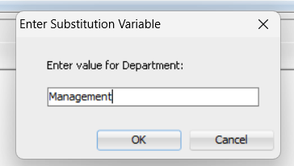

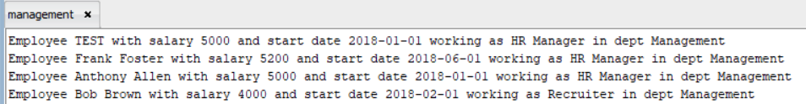

9.2. Търсене на служител по позиция

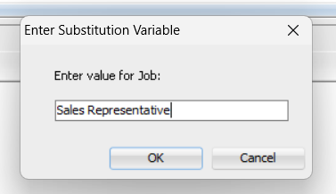

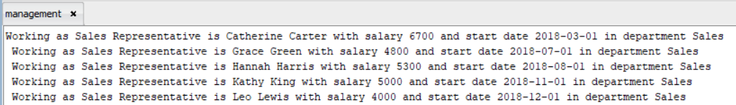

9.3. Търсене по номер на позиция
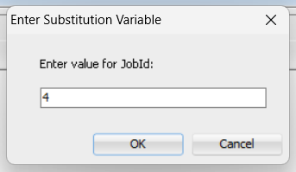

9.4. Търсене на служител по говорим език

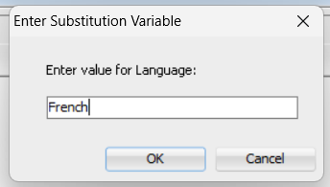

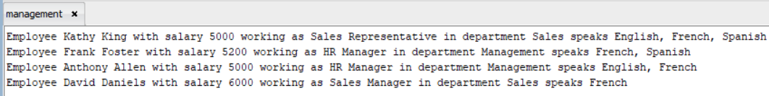

9.5. Извеждане последните петима назначени служители по дата

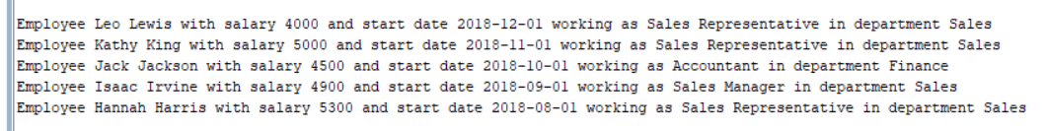

9.6. Извеждане служители по длъжност, подредени по отдел

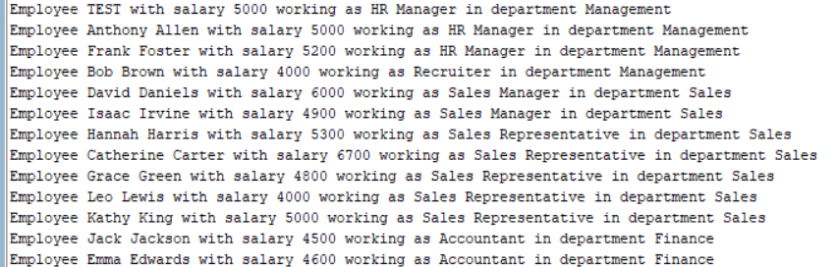

9.7. Извеждане назначени служители за период
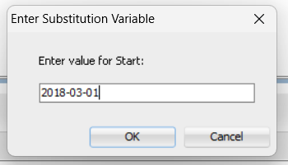
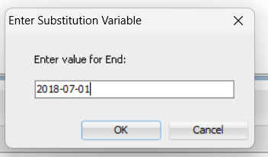

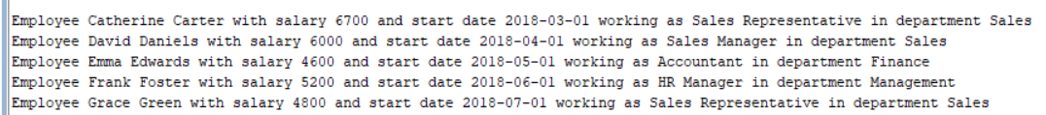

9.8. Извеждане служители без отсъствия за даден месец
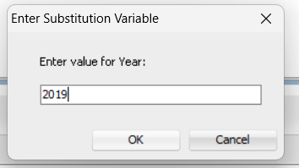
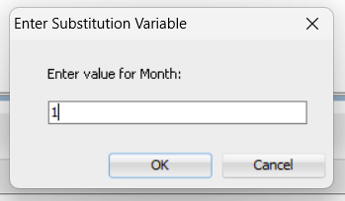

9.9. Търсене по заплата

